MLaaS platforms survey

Azure ML Studio, Amazon SageMaker, IBM Watson, Google AI

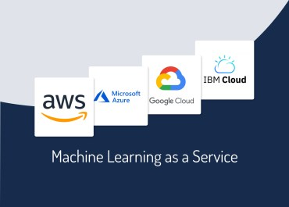

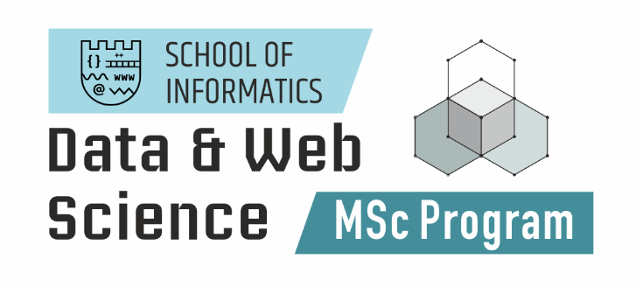

Georgios Michoulis 82

Vasilios Moschopoulos 59

Index

Index of Tables 3

Introduction 3

2. Azure Machine Learning 4

2.1 MICROSOFT AZURE MACHINE LEARNING STUDIO 4

2.2 MICOSOFT AZURE MACHINE LEARNING PYTHON SDK 7

2.3 MICROSOFT AZURE MACHINE LEARNING ARCHITECTURE 7

3. IBM Watson 8

3.1 WATSON STUDIO 9

3.2 IBM WATSON AUTOAI 10

4. AWS SageMaker 11

4.1 SAGEMAKER OVERVIEW 12

4.2 SAGEMAKER PYTHON SDK AND AWS PYTHON SDK (BOTO3) 13

4.3 SAGEMAKER WORKFLOW 14

4.3.1 *WORKFLOW OVERVIEW* 14

4.3.2 *WORKFLOW AND COMPONENTS* 15

5. Google AI Platform 16

5.1 AI PLATFORM OVERVIEW 16

5.2 MANAGING JOBS AND MODELS IN AI PLATFORM 17

5.3 AI PLATFORM WORKFLOW 18

5.3.1 *WORKFLOW OVERVIEW* 18

5.3.2 *WORKFLOW COMPONENTS* 20

6. Comparison 22

7. Conclusion 26

8. References (IEEE) 26

Index of Figures

Figure 1. The drag-n-drop module of Azure ML studio 4

Figure 2. Azure Auto ML 5

Figure 3. Features configuration 6

Figure 4. Models and Metrics 6

Figure 5. Azure ML Architecture 8

Figure 6 IBM Watson Studio 9

Figure 7 AutoAI visualizes the entire model creation process 11

Figure 8. The SageMaker Studio IDE. On the left bar the main UI components are displayed in that order: File explorer, Running Terminals and Kernels, Git, Commands, Experiments, Tools, Endpoint monitoring, Open Tabs 13

Figure 9. A diagram of SageMaker architecture key concepts 14

Figure 10. The SageMaker workflow and its components 15

Figure 11. The AutoML Vision Cloud Console interface 17

Figure 12. The ML lifecycle in AI Platform 17

Figure 13. The different workflow steps and components in AI Platform 20

Figure 14. Example of a Kubeflow pipeline in AI Platform 22

# Index of Tables

Table 1 Frameworks & Pricing 22

Table 2 Built-in algorithm comparison across platforms 24

# Introduction

In the 21st century, AI has become an important area of research and it is implemented in all kinds of fields: Engineering, science, education, medicine, business, accounting, finance, marketing, economics, stock market, and law among others [1]–[5]. AI also influences the larger trends in global sustainability. Artificial intelligence can be useful to solve critical issue for sustainable manufacturing (e.g., optimization of energy resources, logistics, supply) [6].

The development of ML as an AI branch is now very quick. ML has multiple applications and refers to different areas that are commonly used in smart manufacturing, such as learning machines. In addition, deep learning is a branch of machine learning where vast numbers of data are used to learn from neural networks - algorithms inspired by the human brain. Via deep layers that allow progressive learning, deep learning algorithms perform a task repeatedly and gradually improve the result. It is part of a larger family of neural networks-based deep learning techniques.

Around the same time, with the popularization of sensors and mobile devices capable of linking to a network (e.g. the Internet of Things), it is becoming possible to obtain more data at greater levels of information from particular contexts. It is possible to extract much more accurate information and create richer knowledge using machine learning algorithms by connecting global and context sensitive data.

Big corporations have the money to invest in their own innovations for machine learning. Small companies, engineers and re-searchers in general have difficulties when meeting the steep learning curve on how machine learning works and when creating their own software or working with third parties. In addition, with high costs, machine learning can require computing resources [7].

The development of a practical and ready-to-use Machine Learning as a Service (MLaaS) framework is one way of fulfilling this requirement. Machine learning as a service (MLaaS) is an aggregate concept of numerous cloud-based systems that solve, with additional prediction, most infrastructure issues such as data pre-processing, model training, and model assessment. Prediction results can be bridged with your internal IT infrastructure through REST APIs.

In this survey we discuss and compare the state-of-the-art and biggest companies which provide MLaaS, i) Microsoft Azure, ii) IBM Watson, iii) Amazon SageMaker and iv) Google A.I. Finally, we compare all the platforms and we conclude with the best platform so far.

# 2. Azure Machine Learning

Microsoft Azure Studio was first released in 2015. ML Studio (**classic**) is our first drag-and-drop machine learning builder in the literature. It is a standalone service that only offers a visual experience. Studio (classic) does not interoperate with Azure Machine Learning.

## 2.1 MICROSOFT AZURE MACHINE LEARNING STUDIO

Azure Machine Learning platform is aimed at setting a powerful playground both for newcomers and experienced data scientists. Datasets, models, classification, training/testing, pre-processing can be implemented fully with the graphical interface [8].

Services from Azure can be divided into two main categories: Azure Machine Learning Studio and Python SDK [9]. Azure Machine Learning Studio is the online platform for low-code and no-code options for model testing and asset management in Azure Machine Learning. Inside the workflow, the Azure ML graphical interface visualizes each step and encourages newcomers. The main benefit of using Azure is the variety of algorithms available to play with (supervised or unsupervised). This includes data exploration, preprocessing, choosing methods, and validating modeling results. Studio supports around 100 methods that address classification (binary and multiclass), anomaly detection, regression, recommendation, and text analysis k-means.

Azure machine learning studio is an online MLaaS environment provided by Microsoft with use for the designer to train and deploy machine learning models without writing any code. It can perform with simple drag-and-drop datasets and modules to create ML pipelines as shown in Figure 1 [9].



Figure 1. The drag-n-drop module of Azure ML studio

Another big part of Azure ML Studio is the Automated ML UI. To determine the right model based on a performance metric, automatic machine learning easily iterates over several combinations of algorithms and hyperparameters [9]. Since it is completely integrated with UI, it does not require knowledge of any programming language. On Figure 2 we see a snapshot of the Automated ML UI the step that creates a machine learning project and let the user to choose between many choices for the model training such us, the virtual machine the model will run (size, cores, storage, ram), the nodes that will run parallel, the idle time before the cluster is automatically scaled down to the minimum node count [9].

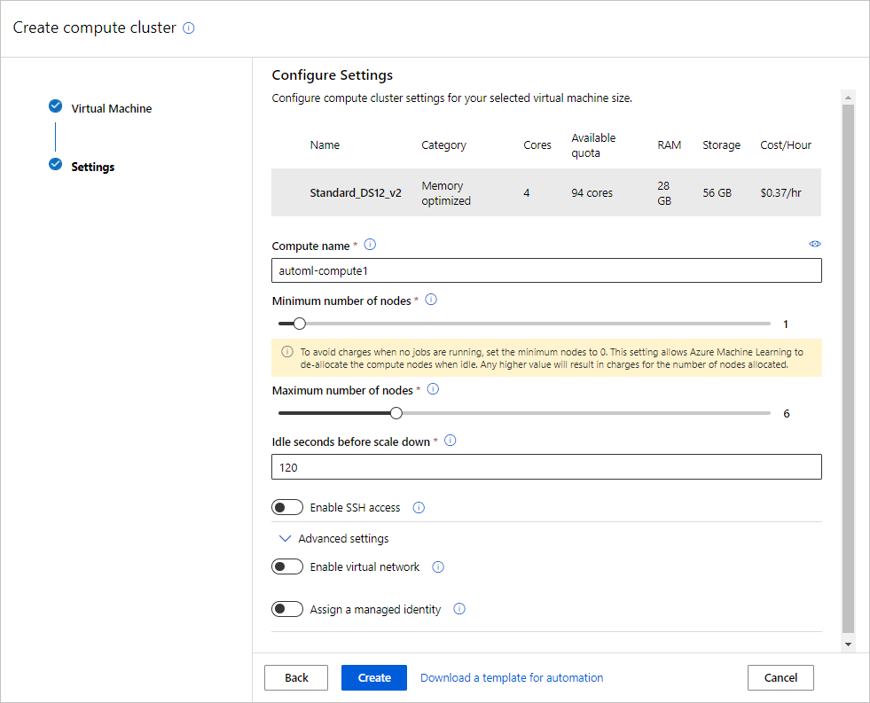

Figure 2. Azure Auto ML

So, the next step is to configure and deploy the model. The configuration part enable user to choose which problem he wants to solve, a classification one or a regression one [9]. The Figure 3 shows a classification problem, and the user can choose which features he does not want to include them for featurization in this experiment. Additional configurations that Azure ML provides are:

* **Primary metric**: Evaluation metric that the machine learning algorithm will be measured by.
* **Explain best model:** Automatically shows explainability on the best model created by automated ML.
* **Blocked algorithms**: Algorithms you want to exclude from the training job.
* **Exit criterion**: If a criterion is met, the training job is stopped.
* **Validation**:  A cross-validation type and number of tests.
* **Concurrency**: The maximum number of parallel iterations executed per iteration



Figure 3. Features configuration

After deployment the Azure Auto ML runs several models for the classification problem (**VotingEnsemble**, StandardScaler etc.). The user can check the chose the best performance model with simple comparison on the AUC weights. After that, a user can extract the metrics he wants and visualize them in order to criticize the results as shown in Figure 4.



Figure 4. Models and Metrics

The Azure ML Studio assists data scientists who wish to simplify part of their ML workflow in order to spend more time on other business priorities. It also makes AI open to a broader community of enterprise users who have little knowledge of data science and coding. On the other hand, Azure ML provide also a framework for more experienced data scientists who wants to fully control their data, model and predictions. For this purpose Microsoft extended Azure ML functionality with the creation of the Azure Python SDK.

## 2.2 MICOSOFT AZURE MACHINE LEARNING PYTHON SDK

Microsoft created their own python SDK, azureml which is an easy-to-use SDK that anyone can install with pip. Azure Machine Learning is a separate and modernized service that delivers a complete data science platform. It supports both code-first and low-code experiences. Also, it can run both locally and remotely and uses MLOps approach. The SDK has at least 25 packages with the most important to be the [10]:

* core: Contains core packages, modules, and classes.
* dataprep: Contains functionality for running common data preparation tasks.
* train-core: Contains estimators for generic and DNN training and also estimator for sklearn.
* pipeline-core: functionality for pipelines, which are configurable machine learning workflows.
* pipeline-steps: Contains pre-built steps that can be executed in an AML pipeline.

It is quite important that the pipeline experiment functions are supported by the azure python sdk. Pipelines for machine learning can build and handle workflows that incorporate phases of machine learning. For example, a pipeline might include data preparation, model training, model deployment, and inference/scoring phases. It is quite important that the pipeline experiment functions are supported by the azure python sdk. Pipelines for machine learning can build and handle workflows that incorporate phases of machine learning [10].

Furthermore, Azure ML SDK automatically iterates through algorithms and hyperparameter settings to find the best model for running predictions. This functions only locally, but it is possible to upload the dataset online to the ML studio and fetch the code back locally. An significant aspect of this technology is the Jupyter notebook, which is used for better comfort for many data scientists. A machine learning model you have studied outside of Azure Machine Learning can be implemented with AML [10]. Moreover, with Azure ML SDK is possible to train models either locally or by using cloud resources, including GPU-accelerated model training.

Nowadays, most companies facing more complex problems. That is why Azure ML is capable to deal with those problems because it can be combined with the state-of-the-art technologies right now such as, Scikit-learn, TensorFlow, Keras, Ray RLlib, PyTorch, ONNX Runtime, MLflow, Docker and REST API. Not only it can be combined with other frameworks but also it can be deployed as an a web service to communicate with the end users and it can be also developed to an IoT Edge device, which is out of the scope of Machine Learning field, but very helpful for the corporations.

## 2.3 MICROSOFT AZURE MACHINE LEARNING ARCHITECTURE

A machine learning workspace is the top-level resource for Azure Machine Learning.

The workspace is the centralized place to manage resources for training and deployment of models, such as computes and store assets, including [9]:

* **Environments**. Those represent the encapsulation of the environment where training or scoring of your machine learning model happens. The environment specifies the Python packages, environment variables, and software settings around your training and scoring scripts.
* **Experiments**. An experiment is a grouping from a given script with several runs. It's still part of the workspace. Inside the experiment, data for the run is processed.
* **Pipelines**. A pipeline endpoint is a series of pipelines which are released. This abstract organization, using the same endpoint, handles and calls several pipelines. In a pipeline end-point, each published pipeline is versioned.
* **Datasets.** Datasets are accessible remotely and locally. Microsoft provides some sample datasets in order to experiment with the models. Azure supports only two types of datasets, the FileDatasets and the TabularDatasets.
* **Models.** A model is a piece of code that takes an input and generates an output at its simplest. Selecting an algorithm, supplying it with data, and tuning hyperparameters is involved in developing a machine learning model. Training is an iterative method that creates a qualified model that encapsulates what the model has learned through the process of training.
* **Endpoints**. An endpoint is an instantiation of your model into either a web service that can be hosted in the cloud or an IoT module for integrated device deployments.

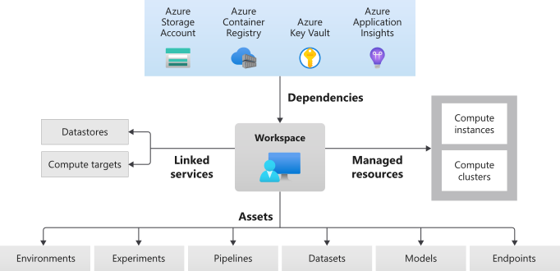

Figure 5. Azure ML Architecture

# 3. IBM Watson

IBM Watson Machine Learning [11] aims to speed AI and machine-learning implementation through data scientists and developers. Watson Machine Learning allows organizations to automate and harness AI on a scale across every cloud with its free, extensible model operation.

For both advanced data scientists and beginners in the area, IBM proposes a single machine learning platform. It provides catalog by Watson Knowledge Catalog, which can be used to share assets between projects. Moreover IBM Watson provides functionalities such as:

* Deploy models built with IBM Watson Studio and open source tools.
* Dynamically retrain models.
* Automatically generate APIs to build AI-powered applications.
* Manage models through integration with Watson OpenScale.
* Streamline model management and deployment end-to-end with an easy-to-use interface.

## 3.1 WATSON STUDIO

In a scalable hybrid cloud environment, IBM Watson Studio [12] is a forum for companies to develop and train AI and machine learning models and to plan and analyze data. Watson Studio offers data scientists, technology developers, and subject matter experts with tools to communicate and interact effectively with data to create and train scale models. With Watson is possible to build predictive models with or without coding leveraging a best-of-breed combination of self-service, no-code, visual modeling tools and open-source capabilities.

IBM Watson Studio Premium (Subscription) consists of IBM Decision Optimization, IBM SPSS Modeler and Hadoop Execution Engine. Forrester Research (link resides outside IBM) found that SPSS Modeler enabled a 40% productivity improvement for data scientists and an ROI of 480%. SPSS is one of the most popular technologies that every data scientist and statistician uses, therefore this kind of user does not need to learn new tools or buy new tools, because they can use ML models from the SPSS.

IBM Watson is further divided in Local 2.0, Desktop and, Cloud edition. The desktop edition incorporates the most common parts of Watson Studio Cloud and Microsoft Windows or Apple Mac PC applicable. IBM SPSS Modeler, notebooks and IBM Data Refinery are currently provided in a single installation to provide you with efficient and flexible data processing and modeling capability. Watson Studio Local is software to be deployed on premises inside the firewall, whereas Watson Studio Cloud is part of the IBM Cloud, a public cloud platform.

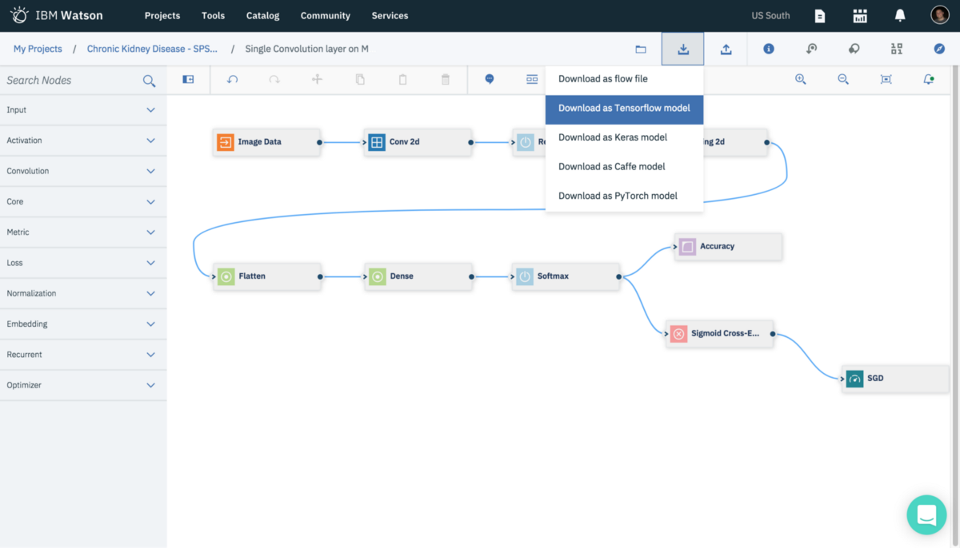

Figure 6 IBM Watson Studio

The most important differences between Local 2.0 and Cloud edition are that the first provides v4 APIs and integrates Watson Machine Learning Accelerator [13] while the second is able to collaborate in deployment spaces, provides continuous learning and batch jobs. The key capabilities of Watson Machine Learning Accelerator are:

* Elastic Distributed Training: Simplifies the distribution of training workloads for data scientists
* Automated Hyperparameter Optimization: Helps data scientists optimize the speed of training by automating hyperparameter searches in parallel
* Accelerated machine learning library with SnapML: An efficient, scalable machine learning library that enables fast training of various machine learning models
* Elastic Distributed Inference: Publish inference models as services

IBM Watson Studio supports state-of-the-art machine learning frameworks like PyTorch, Caffe, Keras, Tensorflow and SPSS and offers plenty services and third-party services like, Cloud Object Storage, BigInsights, and Amazon S3, Google Cloud Storage, Microsoft Azure Data Lake Store, Oracle. Finally, an extra but really important feauture of Watson Studio is the IBM Watson Machine Learning Server, which is single-node server. It is possible for analytical assets such as SPSS Modeler flows and machine learning model notebooks from Watson Studio Desktop to be able to be deployed to the Watson Machine Learning server, which is more scalable and there it CPU-limitless. This feauture is extra and it is not included in the premium edition. The Watson SDK is also applicaple with other MLaaS platforms such as Azure and SageMaker [14].

## 3.2 IBM WATSON AUTOAI

IBM AutoAI [15] is an experience that helps business users apply AI tools through the process of data preparation, analysis, and model creation and training. Organizations attempting to apply AI to their market and data processes usually struggle with a capabilities shortage, as well as a lack of expertise in their program implementation and governance. IBM AutoAI allows customers simplify AI processes to assist with their organization's dynamic enterprise and data activities. Jobs like sorting through data and organizing it to prepare for analysis usually take a lot of time and effort for data scientists. IBM Auto AI empowers users to create the templates they need to automate these activities effectively. Results are shown on a leaderboard, displaying the model pipelines created automatically. In Watson Studio, the graphical tool AutoAI is implemented. AutoAI automatically runs the following tasks to build and evaluate candidate model pipelines:

* **Data pre-processing**. In order to evaluate, disinfect, and prepare the raw data for machine learning, AutoAI applies different algorithms, or estimators. It detects and categorizes features automatically based on data type and uses hyper-parameter optimization to decide the best combination of missed meaning imputation techniques, attribute encoding, and scaling of the data features.
* **Automated model selection**. AutoAI uses an innovative approach that allows candidate algorithms to be evaluated and graded against small subsets of results, steadily increasing the size of the subset to arrive at the best fit for the most promising algorithms. It also requires a huge range of candidate algorithms to be ranked and the best fit for the data is chosen.
* **Automated feature engineering**. AutoAI uses a novel approach that examines different function construction options in a systematic, non-exhaustive way, while using reinforcement learning to steadily optimize model accuracy. This results in an optimal transition series for the data that better fits the model selection stage algorithms.
* **Hyperparameter optimization**. AutoAI uses a novel hyper-parameter optimization algorithm optimized for costly function evaluations such as model training and scoring that are typical in machine learning.

AutoAI [16] uses a model-based, derivative-free global search algorithm, called RBfOpt, which is tailored for the costly machine learning model training and scoring evaluations required by hyperparameter optimization (HPO). RBfOpt fits a radial basis function mode to speed up the exploration of hyper-parameter configurations that optimize the objective function of the machine learning problem at hand, in comparison to Bayesian optimization that fits a Gaussian model to the unknown objective function. This acceleration is achieved by minimizing the number of expensive training and scoring machine learning models evaluations and by eliminating the need to compute partial derivatives. For each fold and algorithm type, AutoAI creates two pipelines that use HPO to optimize for the algorithm type:

* The first is based on optimizing this algorithm type based on the preprocessed.
* The second is based on optimizing the algorithm type based on optimized feature engineering of the preprocessed (imputed/encoded/scaled) data set.

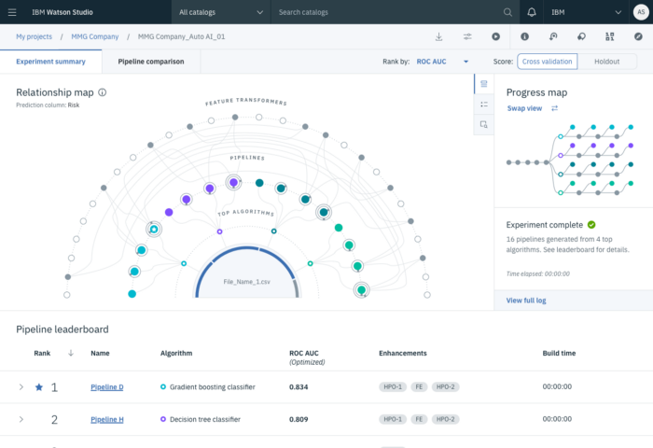

Figure 7 AutoAI visualizes the entire model creation process

# 4. AWS SageMaker

In this section we examine SageMaker [17], a cloud machine-learning platform that was launched in November 2017 by Amazon Web Services. SageMaker enables developers to create, train, and deploy machine learning models on the cloud. SageMaker also enables developers to deploy models on embedded systems and edge devices.

## 4.1 SAGEMAKER OVERVIEW

SageMaker is a fully managed and complete machine learning service and data science solution for exploring and processing data, human labeling services, model training, debugging and deployment, for both regular services and edge/IoT, as well as model exploration and AutoML [18].

With SageMaker, data scientists and developers are given access to Jupyter notebook running on managed instances. AWS have come up with quite a lot of sample notebooks with written solutions for a wide range of problems using built-in algorithms. Those algorithms are highly optimized to run efficiently against extremely large data in a distributed environment. For a given problem, one can reuse a sample notebook to build and train models easily and quickly, and then directly deploy them into production-ready hosted environments in AWS. Moreover, it supports custom-made algorithms and frameworks, making it a much more flexible service for various needs. SageMaker built-in algorithms include a linear learner, factorization machines, image classification, a sequence-to-sequence model, K-means, Principal Component Analysis and XGBoost [19]. For ready-model packages, algorithms and data products, developers can alternatively navigate the AWS Marketplace.

SageMaker also offers an integrated and complete web IDE, SageMaker Studio [20], which makes managing instances and jobs easier, and is recommended by AWS. SageMaker Studio makes things easier, faster, and more secure by automatically managing all needed resources on the fly.

SageMaker does not provide a drag-and-drop tool like many other platforms and instead follows a from-developers-for-developers and developer-first approach, similar to many other AWS products.

A simpler and more accessible alternative to SageMaker is Amazon Machine Learning. In recent years, however, Amazon seems to be capitalizing on its more powerful AI services, like SageMaker, instead. Amazon ML documentation has not been updated since 2016.

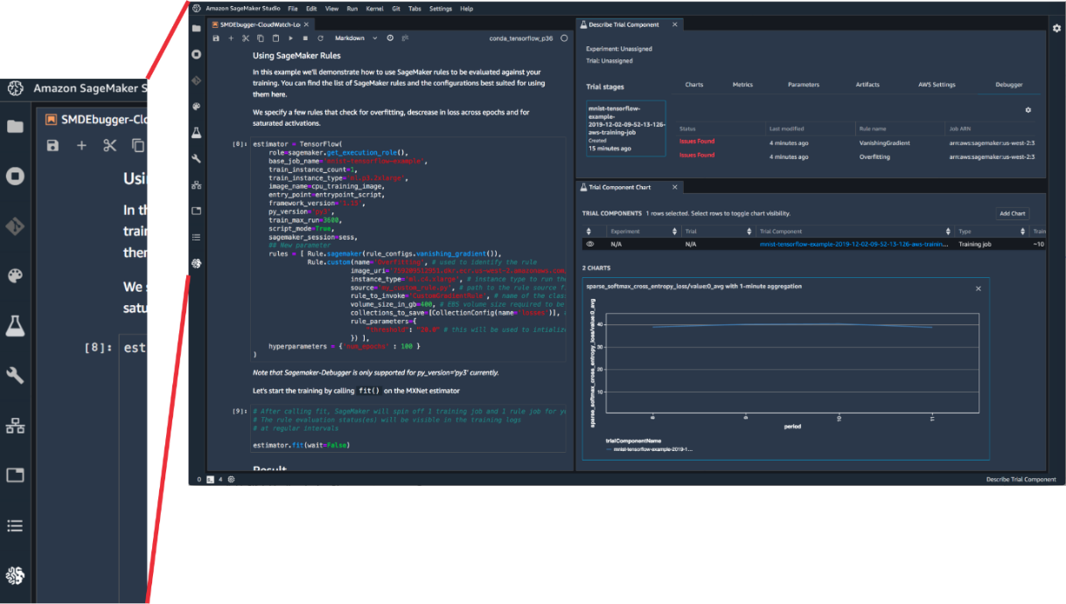

Figure 8. The SageMaker Studio IDE. On the left bar the main UI components are displayed in that order: File explorer, Running Terminals and Kernels, Git, Commands, Experiments, Tools, Endpoint monitoring, Open Tabs

## 4.2 SAGEMAKER PYTHON SDK AND AWS PYTHON SDK (BOTO3)

For the purposes of SageMaker alone, AWS have developed a separate Python SDK, which can run both locally and remotely. The SDK allows developers to manage the models, jobs, and pipelines through Python code. The SDK is available through both the Anaconda and the pip installer.

The SageMaker SDK provides several high-level abstractions for working with SageMaker [21]:

* **Estimators**. Those encapsulate training on SageMaker
* **Models** encapsulate built ML models
* **Predictors** provide real-time inference and transformation using Python data types against a SageMaker endpoint
* **Session** provides a collection of methods for working SageMaker resources
* **Transformers** encapsulate batch transform jobs for inference on SageMaker
* **Processors** encapsulate running processing jobs for data processing on SageMaker

Alternatively, one can also use the general Python AWS SDK, Boto3 [22]. Boto3 is also available with both the Anaconda and the pip installer and can run both locally and remotely.

Both SDKs can easily be combined with all popular machine and deep learning frameworks including Spark/PySpark, MXNet, Tensorflow, PyTorch, Scikit-learn, Chainer, Gluon as well as R models [23].

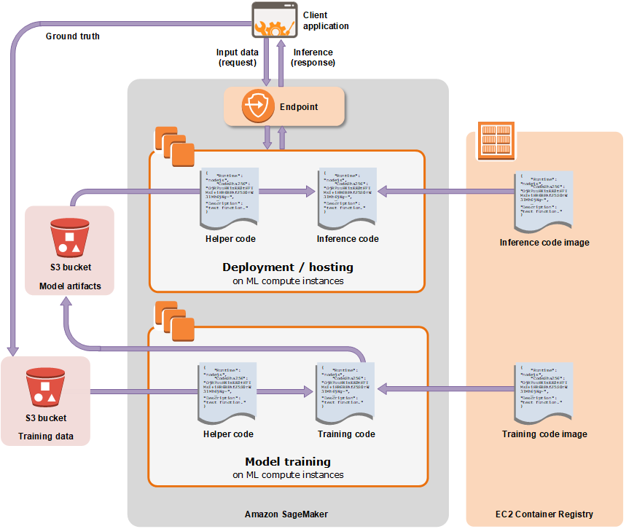

Figure 9. A diagram of SageMaker architecture key concepts

## 4.3 SAGEMAKER WORKFLOW

In this subsection we present the typical workflow for developing and deploying data science solutions on the cloud with SageMaker. We begin by providing a general overview [17] and then delve deeper on the several different stages and components of the workflow [18].

### 4.3.1 *WORKFLOW OVERVIEW*

The workflow in SageMaker works like this:

The developer pulls the training data from an S3 bucket and proceeds to preprocess them. After performing Exploratory Data Analysis on a notebook with various functions, they proceed to build the training code for the model. Alternatively, the developer can select from ready-made notebooks to use with their data.

All algorithms are hosted in Docker containers, so, for the training job one needs to define algorithm and training job parameters. Training jobs are then sent to a single or multiple ML M4 instances. Developers can also bring their own models or custom Docker containers for training. Such containers, however, need to have a specific structure. A Dockerfile needs to be laid out for building the container and then the container should be pushed to ECR, which is a Docker image service in AWS.

After training is complete, one can host the model in yet another container, which will be deployed on an ML C4 endpoint instance. Multiple models can be hosted for A/B testing to test which one performs best.

Lastly, deployed models can be validated, and endpoints can be deleted when the model is no longer in use.

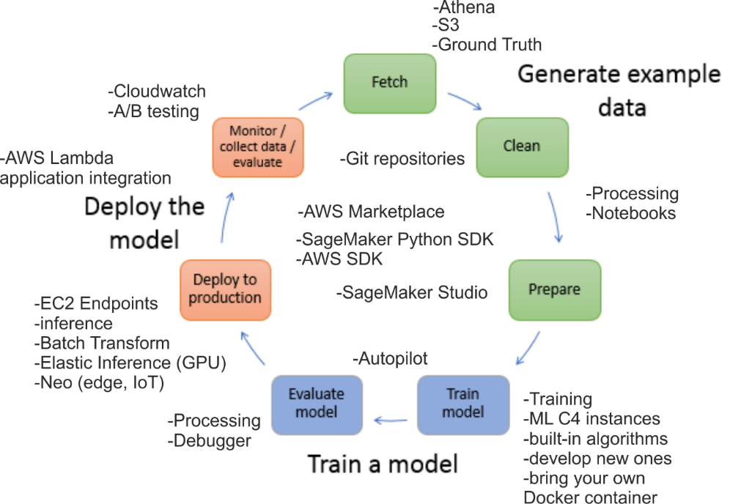

Figure 10. The SageMaker workflow and its components

### 4.3.2 *WORKFLOW AND COMPONENTS*

**Fetch** The workflow begins by fetching the training data. This can happen either through AWS Athena; a data and big data querying service; upload of a custom dataset, or a manually labeled dataset, with the help of Ground Truth. Ground Truth is a human labeling service. Ground Truth services are provided through the AWS Marketplace by different vendors and can be bought at a specified price. Training data should be stored in an S3 bucket to be accessible for model training.

**Clean** and **Prepare** After the data has been fetched, they need to be cleaned and prepared to be used by a model. For data processing Notebooks are used. Notebooks can also be associated with Git repositories. In the process of all this, SageMaker Studio can aid in automating Notebook instances creation, model deployment, as well as model experimentation (AutoML), and is highly recommended. Processing pipelines can also prepare data for model input, this service, however, can be used with deployed models only.

**Train model** For model training, C4 instances are used with built Docker containers. Such containers can either be the result of Notebook experimentation, ready-made containers from the AWS Marketplace, or custom-made containers brought by the developer. Containers always contain a model. The model can either the result of experimentation, built-in models provided by AWS, bought models from the AWS Marketplace or ready-made models provided by the developer. It is worth noting that SageMaker Studio also comes with an Autopilot service, useful for automating model building and experimentation.

**Evaluate model** SageMaker provides a Debugger tool for debugging models. The Debugger helps visualize model architecture, and aids in identifying errors in modeling and improving architecture. For deployed models, the Processing service can also be used for gaining insights of how deployed models can be further improved.

**Deploy to production** EC2 endpoints are used for hosting models, through which model inference can be achieved. Inference can either be online or offline, with the use of the Batch Transform service. Batch Transform helps process large data and split them into smaller batches, delaying however the endpoint response. Models can also be hosted on GPUs for faster inference, with the Elastic Inference service, or deployed for edge and IoT usage, with SageMaker Neo. For model integration with software applications, the AWS Lambda service is used.

**Monitor / collect data / evaluate** Finally, after a model has been deployed, it can be monitored using the Cloudwatch service or by performing A/B testing. It is also worth noting that SageMaker Studio provides functionality for monitoring hosted model endpoints.

# 5. Google AI Platform

In this section we examine the Google AI Platform [24]. AI platform was released In 2018 by Google to offer its customers the ability to train their own machine learning models and deploy data science solutions. The Google AI Platform is part of the Google Cloud Platform (GCP), which is a suite of cloud computing services that runs on the same infrastructure that Google uses internally for its end-user products.

## 5.1 AI PLATFORM OVERVIEW

AI Platform is a suite of services on Google Cloud specifically targeted at building, deploying, and managing machine learning models on the cloud. It is designed to make it easy for data scientists and engineers to streamline ML workflows and access groundbreaking AI developed by Google. AI Platform offers a collection of services, designed to support the activities seen in a typical ML workflow.

AI Platform, like many other platforms, comes with a variety of supported built-in algorithms, including a linear learner, Wide and Deep, TabNet, XGBoost, image classification and an object detection model [25].

AI Platform Classic supports training, prediction, and version management of advanced models. A Unified version of AI Platform also provides a separate point-and-click ML engine service, called AutoML [26]. AutoML comes in multiple flavors including ML Vision, Video Intelligence, Natural Language, Translation and Tables.

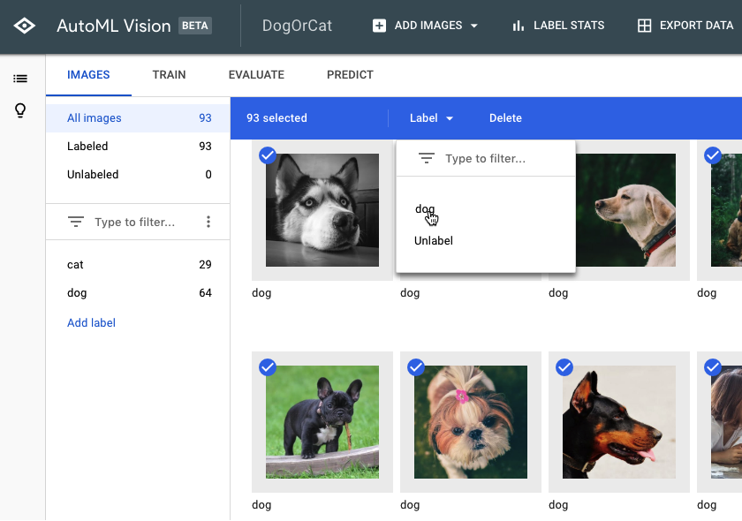

Figure 11. The AutoML Vision Cloud Console interface

## 5.2 MANAGING JOBS AND MODELS IN AI PLATFORM

Managing jobs and models in Google AI Platform is relatively different to other platforms due to the fact it lacks a Python SDK, as most platforms do.

Job and model management is instead achieved in four different ways [24]. The first one is through a web user interface, the Cloud Console, as it is referred to. This is accessible through a browser only. The second involves the gcloud CLI with the use of the ai-platform command. The command includes five different command groups: jobs, local, models, operations, and versions. The third way is through the AI Platform Training REST APIs while the fourth one includes accessing those APIs through the Google Python client library.

It is also worth mentioning that the AI Platform supports the Tensorflow, Scikit-learn, PyTorch and XGBoost frameworks, as well as R.

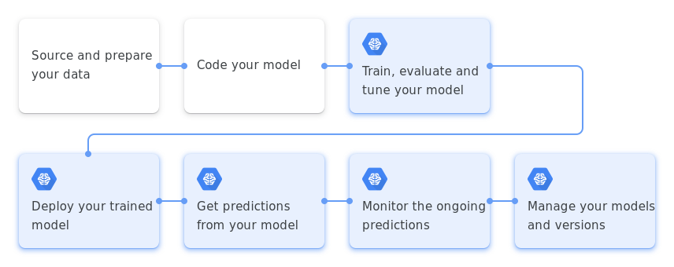

Figure 12. The ML lifecycle in AI Platform

## 5.3 AI PLATFORM WORKFLOW

In this subsection we present a typical workflow in AI Platform. We begin by providing a general concept of the workflow, and an overview [27], and proceed to analyze the different components that belong to each workflow step [28].

### 5.3.1 *WORKFLOW OVERVIEW*

**Problem evaluation** Before proceeding to build the data science solution the developer should evaluate the problem they want to solve. Things the developer should consider include whether the problem is well-defined, if machine learning is indeed the best solution and how the model’s success can be measured.

If the goal of the problem is not clear the developer should work on defining the different parts of it before the next step. Some times, machine learning may also not be necessary. Simple problems in software can simply be analyzed with Exploratory Data Analysis and solved with an easy modification to the code instead. However, if machine learning is indeed necessary, the developer should also take into account the different measuring techniques and pick the best one. In many classification problems accuracy is not a good indicator of model success and recall, precision and F1 score can provide a clearer insight. Measures also vary depending on the model’s goal. Classification and regression are very different approaches and measures used for one cannot be used for the other.

**Data preparation** After the developer has settled on the problem’s details, data preprocessing naturally follows. Data analysis must be performed to gain insights on the problem and then data needs to be transformed into a ready-to-input format for the model.

Data preparation is typically performed with Notebooks. Other options include:

* The Deep Learning VM Image service, which provides instances pre-packaged with JupyterLab notebooks and optimized for data science,
* BigQuery, a data warehouse service that allows ad hoc analysis on real-time data with SQL,
* Dataproc, a cloud service for running Apache Spark and Hadoop clusters,
* Dataflow, a service for transforming and enriching data in stream and batch models with equal reliability and expressiveness, and
* Dataprep, an intelligent, serverless data service for visually exploring, cleaning and preparing structured and unstructured data.

In Notebooks, data preparation can also be performed in the form of pipelines, provided by either the Scikit-Learn or the TensorFlow framework.

**Training process** The developer should then code their model, train, evaluate and further tune it. The developer has many options when it comes to model building, with several supported frameworks by the AI Platform.

The training process works like this:

* First, one must create a Python application that trains the model and build the solution as one would normally would to run locally.
* Then, the training and verification data should be put into a source the Training service can access.
* When the application is ready to run, the developer must package it and transfer it to a Cloud Storage bucket that the project can access.
* The Training service sets up resources for the job and allocates one or more virtual machines (training instances) based on the job configuration. Training instances are set up using the standard machine image for the Training version of the job and by loading and installing needed application packages and other additional dependencies using pip.
* The Training service runs the application, passing through any specified command-line arguments.
* To get job information the developer can either go to Cloud Logging, request job details, run log streaming with the gcloud CLI, or programmatically make status requests to the service.
* When the training job succeeds or encounters an unrecoverable error, Training halts all job processes and cleans up the resources.

As an alternative to manual model building, developers can select from a range of ready-made built-in algorithms, with a number of training limitations, however.

It is also worth mentioning that distributed model training is an option for developers. Developers can also select to accelerate model training using GPU and TPU instances. Developers should also investigate and debug their models and perform any necessary hyperparameter tuning. The latter can be achieved using the AI Explanations service, which helps developers comprehend different feature attributions and optimize their models.

**Model hosting** After the model has been trained the developer can host the model in the cloud. To do this, the developer should upload a version of the model to a Cloud Storage bucket and create a model resource on AI Platform, specifying the Cloud Storage path. Afterwards, prediction requests can be sent to the model for inference. The developer can also monitor the model through the Prediction service on an ongoing basis. Different versions of the model can exist and managed by the developer.

All of this is managed by the Prediction service. The Prediction service procedure works like this:

* The developer should first export their model as an artifact.
* Then, a model resource should be created in the Prediction service with the model version.
* Predictions can happen in either an online or offline (batch) fashion:
  + With online predicition, the service provides an endpoint, with the saved model running, and returns the requested predictions as the response message for the call.
  + Batch prediction, on the other hand, supported only by TensorFlow models, allocates resources to run the job, with either one or more prediction nodes, restores the Tensorflow graph on each allocated node and distributes input data across nodes. Then, it runs the graph and saves the predictions to a specified Cloud Storage location. When all input data has been processed, the job is shut down and allocated resources are released.

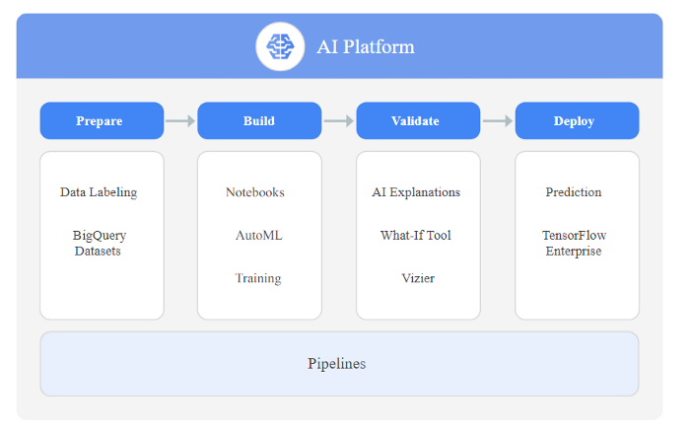

Figure 13. The different workflow steps and components in AI Platform

### 5.3.2 *WORKFLOW COMPONENTS*

In this subsection we present the service components that belong to each of the five steps in the AI Platform workflow. We begin with data preparation components, follow with model building and validation components and end with model deployment components and pipeline components. ML pipeline components specifically belong to a machine learning engineering field called MLOps, which combines machine learning software development and DevOps practices into a combined concept. MLOps accelerates machine learning development and is applied to all steps in the data science workflow, using automated pipelines with different stages.

**Preparation** Before starting to experiment with model building, data preparation is necessary. Although data preparation often seems one of the least interesting concepts in data science, it is in fact the most necessary and time-consuming step in the workflow. For data preparation, two services can be useful:

* **BigQuery Datasets** is a hyper-scale data warehouse that works on Cloud Storage and hosts collections of tables in Google Cloud. This is where data is first prepared (ingestion, cleaning, feature engineering). Although not technically an AI service, BigQuery Datasets is used in 99% of the ML workflows.
* **Data Labeling Service** is a human labelling service for training data. Different vendors exist, with different pricing.

**Build** After data has been prepared model building follows. The AI Platform offers the following services for building:

* **AutoML** is a zero code, drag-and-drop platform with a graphical interface. It relies on Google’s SOTA transfer learning and neural architecture search technology.
* **Notebooks** is a service offering Jupyter notebooks for building custom ML models. Notebooks is a relatively new service that has replaced the older Cloud Datalab. Compared to its predecessor, Notebooks no longer requires to set up an SSH tunnel. Notebooks can use the latest

open-source deep learning frameworks on Deep Learning VM Image or Deep Learning Containers.

* **AI Platform Training** is a service for running training jobs on computing resources in the cloud

**Validate** Besides model training, developers must ensure that their models perform as best as possible. AI Platform provides a set of services that can help developers debug their models, understand them and tune their hyperparameters:

* **Explainable AI** helps understand model outputs, verify model behaviour, recognize bias and get ideas for ways to improve the model and engineer the training data. Explainable AI is useful for hyperparameter tuning and features **AI Explanations**, **What-If Tool** and **Continuous evaluation**.
* **AI Platform Vizier** is a black-box optimization service for hyperparameter tuning and model optimization

**Deploy** After the model is built and validated the next step is to host it in production:

* **AI Platform Prediction** is a service that manages the infrastructure needed to run your model and make it available for online and batch prediction requests.
* **AutoML Vision Edge** helps deploy edge models to be run on smartphones and IoT devices, for example, and can trigger real-time actions based on local data.
* **TensorFlow Enterprise** offers enterprise-grade support for TensorFlow instances.

**ML Pipelines** MLOps practices can accelerate model production and deployment. ML Pipelines services provided by the AI Platform aid in applying those practices:

* **AI Platform Pipelines** is a service providing support for creating ML pipelines, using either Kubeflow Pipelines or TensorFlow Extended (TFX). Kubeflow Pipelines is an open-source platform for running, monitoring, auditing and managing ML pipelines on Kubernets. TFX is an open-source project for building ML pipelines that orchestrate end-to-end workflows.
* **Continuous evaluation** helps monitor the performance of models and provides continual feedback on how models perform over time.
* **Deep Learning VM Image** supports easy provisioning of Cloud VMs for deep learning application.
* **Deep Learning Containers** provide pre-configured and optimized containers for deep learning environments.

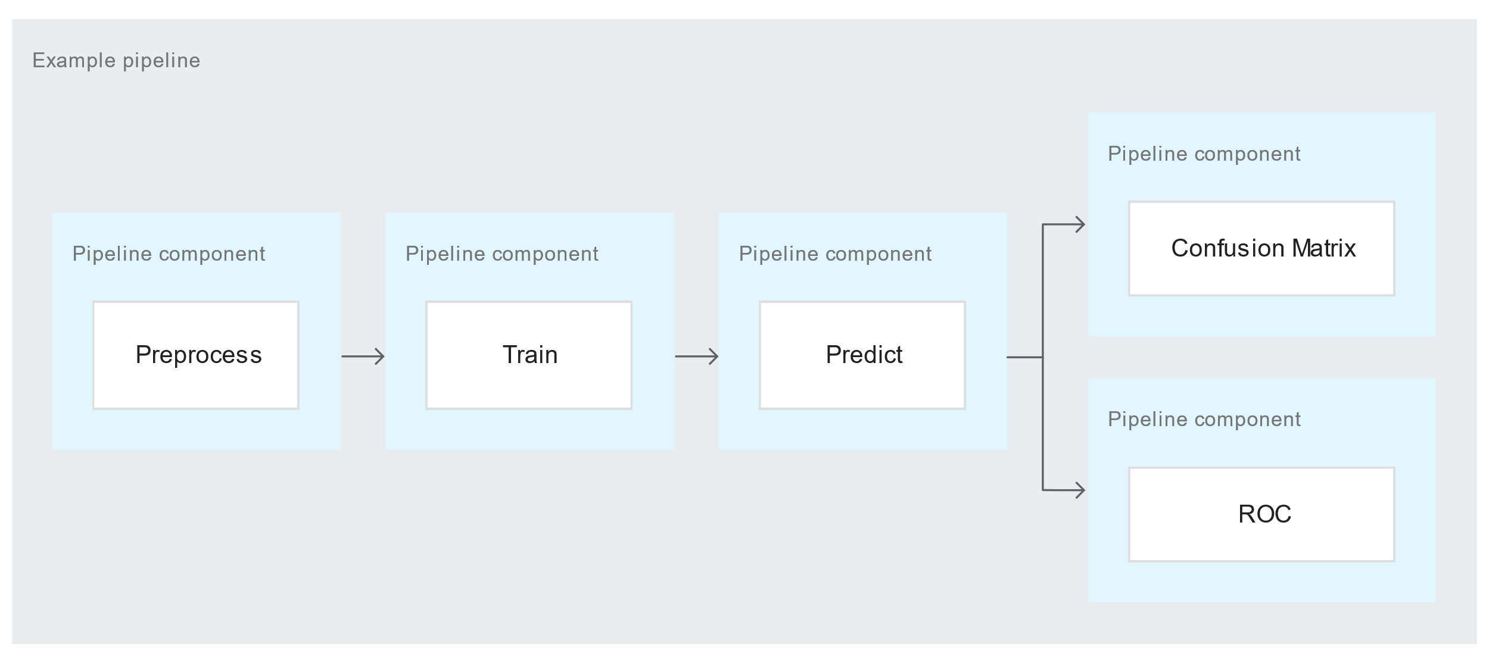

Figure 14. Example of a Kubeflow pipeline in AI Platform

# 6. Comparison

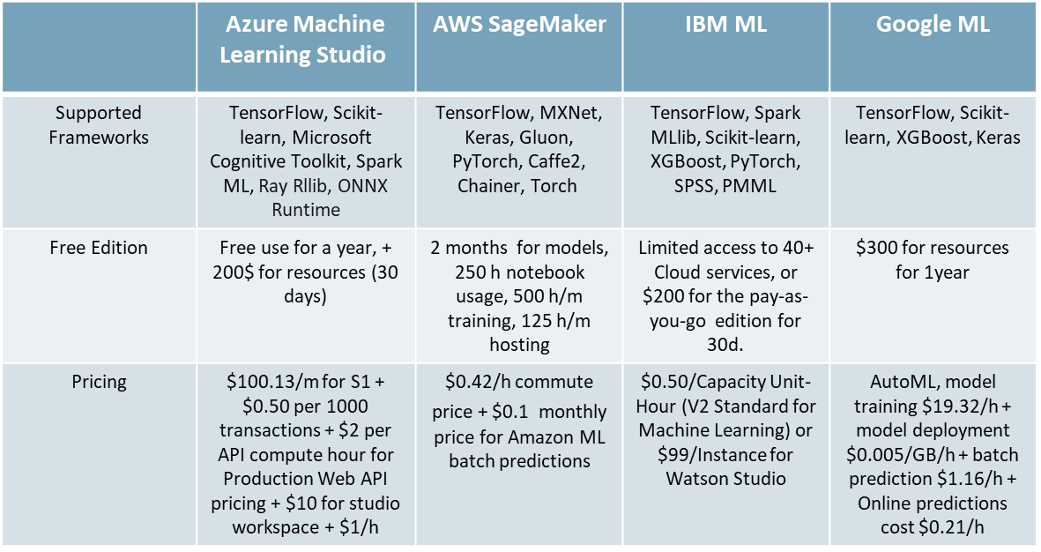

Table 1 Frameworks & Pricing

The supported framewors are very important for the services because it is shows how open and applicable are with the current businesses workaload. Also, they are important for the data scientists to be able to work with familiar tools and make their job easier. The following bullets provide a brief description of each framework of Table 1:

* **Scikit-learn** is an open source machine learning library that supports supervised and unsupervised learning. It also provides various tools for model fitting, data preprocessing, model selection and evaluation, and many other utilities.
* **TensorFlow** is an end-to-end open source platform for machine learning. It has a comprehensive, flexible ecosystem of tools, libraries and community resources that lets researchers push the state-of-the-art in ML and developers easily build and deploy ML powered applications.
* The Microsoft Cognitive Toolkit (**CNTK**) is an open-source toolkit for commercial-grade distributed deep learning. It describes neural networks as a series of computational steps via a directed graph. CNTK allows the user to easily realize and combine popular model types such as feed-forward DNNs, convolutional neural networks (CNNs) and recurrent neural networks (RNNs/LSTMs).
* **Spark ML** or MLlib is Spark’s machine learning (ML) library. Its goal is to make practical machine learning scalable and easy.
* **RLlib** is an open-source library for reinforcement learning that offers both high scalability and a unified API for a variety of applications. RLlib natively supports TensorFlow, TensorFlow Eager, and PyTorch, but most of its internals are framework agnostic.
* **Keras** is the most used deep learning framework among top-5 winning teams on Kaggle. Because Keras makes it easier to run new experiments, it empowers you to try more ideas than your competition, faster. And this is how you win.
* **Caffe2** is a light-weight and modular framework that comes production-ready with ultimate scaling capabilities for training and deployment.
* **Pytorch** is an open source machine learning framework that accelerates the path from research prototyping to production deployment and used mostly for Deep Learning research.
* **Chainer** is a powerful, flexible and intuitive deep learning framework. Supports CUDA, Python and various network architectures including feed-forward nets, convnets, recurrent nets and recursive nets. It also supports per-batch architectures.
* **ONNX Runtime** is a cross-platform inferencing and training accelerator compatible with popular ML/DNN frameworks, including PyTorch, TensorFlow/Keras, scikit-learn, and more.
* The **IBM SPSS** software platform offers advanced statistical analysis, a vast library of machine learning algorithms, text analysis, open source extensibility, integration with big data and seamless deployment into applications.
* **PMML** stands for "Predictive Model Markup Language". It is the de facto standard to represent predictive solutions. A PMML file may contain a myriad of data transformations (pre- and post-processing) as well as one or more predictive models.
* **XGBoost** is an optimized distributed gradient boosting library designed to be highly efficient, flexible and portable. It implements machine learning algorithms under the Gradient Boosting framework.

Each MLaaS platform provide some free services but with stricked limits on resources and period of use. A large-scale company can provide resourced in order to test all platforms, but a small one can not afford to pay for an expensive MLaaS. So, each platfrom provides a free period for testing for a company or a freelancer in order to explore its tools. Free period in each platform provide very limited tools and services, and it is very normal, otherwise they wouldn’t be in top 10 companies in the world. The Table 1 shows a pricing example only for machine learning as a service by each platform. Those prices are a small/medium scale resources and services. So, if someone want more advanced tools for their work, they will have to pay for extra services to achieve better performance and quickest results.

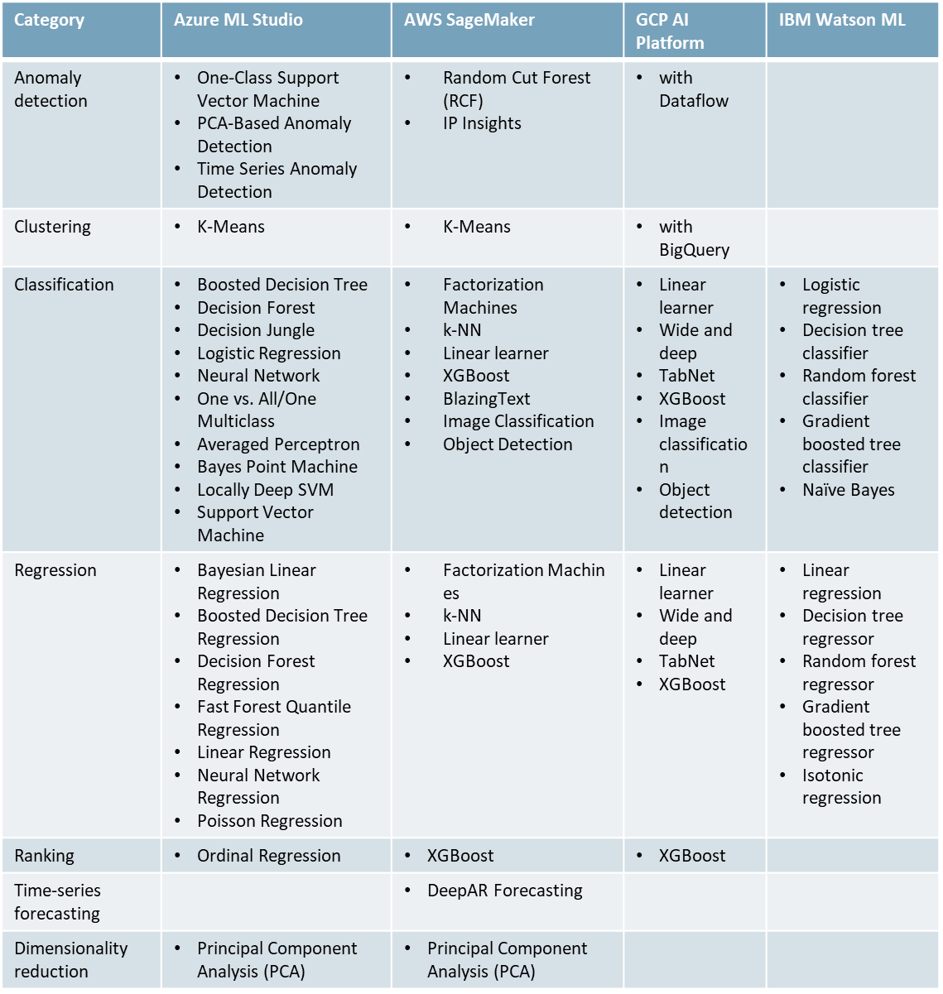

Table 2 Built-in algorithm comparison across platforms

The above table provides an overview of different platform built-in algorithms. Built-in algorithms are an integral part of all ML cloud platforms. Built-in algorithms increase the ML cloud platforms’ ease of use, provide ready templates for developers to use while simultaneously hinting workflow development process for newcomers, and make simple, industry-tailored algorithms ready for deployment, reducing production deployment time.

Out of all platforms, IBM Watson provides the least number of options, focusing instead on robust integration with SPSS and statistical tools. Azure ML and AWS SageMaker provide the most options, with SageMaker being the most sophisticated, and Azure ML focusing on more traditional algorithms instead.

The following bullets provide a brief description of key algorithms:

* **Bayesian machines** are based on the statistical Bayes theorem. The Bayesian framework defines that you start by listing all reasonable models of the data and assigning your prior belief to each of them. Then, by observing the data, you evaluate how likely the data are under each of these models. Bayesian machines include Bayeasian regression and Bayes Point Machines.
* **Linear machines** are based on the linear regression model. The term linear essentially means that the prediction of such algorithms is done by multiplying feature values with learned values (weights) and then summing over to extract the predicted value. A variation of this is the logistic regression, where instead of predicting a continuous value, we aim to classify the output into different classes. Linear machines include Perceptron, linear regression and logistic regression.
* **Decision Trees** are a class of algorithms based on tree-like structures that learn to predict by extracting feature-based rules at each node of the tree. Decision tree algorithms include the Boosted decision trees and Boosted decision tree regression.
* **Random Forests** are an extension to decision trees where the predicted output is performed using a multitude of decision trees, either by using the mode (most common) of the predicted classes or the mean predicted value. An extension to Random Forests is the Decision Jungle.
* **Factorization machines** factorize a larger matrix into the multiplication of two smaller ones. These algorithms are commonly used in recommendation systems.
* **SVMs** are a special type of algorithms that learn to draw a boundary to distinguish between two different classes.
* **K-Means** is an unsupervised clustering algorithm that learns to distinguish between a number of different clusters based on the sample distances from the cluster mean.
* **K-NN** learns to predict a sample based on the class or value of its k nearest neighbors. k values may vary and are determined by the developer.
* **Neural networks** are an extension to linear machines where a number of linear layers are stacked on top of each other to draw more complex spaces, either for predicting values or creating a boundary between different classes. This way neural networks can become deeper. Such deep networks belong to a special kind of machine learning field, called Deep Learning. GCP AI Platform’s Wide and Deep algorithm is a special kind of neural network that combines linear as well as deep layers.
* **Attention networks** are a type of network for giving a certain, learned amount of attention in a tensor context. TabNet is a type of attention network.
* **Image detection algorithms** utilize a certain neural structure called convolutional layers. Convolutional networks perform convolutions across nearby pixels on images to extract new pixel values and incrementally learn to recognize image patterns by stacking multiple layers on top of each other.
* **Principal Component Analysis** (**PCA**) is an unsupervised algorithm for reducing the number of features in a dataset while maintaining as much information as possible. Features constructed by PCA are complex and may not be interpretable, due to the reduction in dimensionality.

# 7. Conclusion

With the rise of machine-learning-aided improved decision making, businesses need to stay on the edge. One of the main contributions of MLaaS is helping small and medium businesses remove the burden of supporting and maintaining data science powerhouses by alleviating such costs, handling data management and removing the worry about sophisticated and large-scale ML and data needs. As a result, such businesses can remain competitive in the market and flourish.

Another contribution of MLaas is accelerating business decision making, by providing faster insights with ready-made built-in algorithms and solutions, specifically tailored to the needs of the industry. Such algorithms increase the ease of use of ML cloud platforms and come deployment ready. It is also worth noting that due to the nature of MLaaS data science powerhouses, such powerhouses can be scaled infinitely and rescaled back to the size of a single computer in a matter of clicks.

ML cloud platforms provide a number of tools and services each business can select from, depending on its needs. Coming at a low cost, such services help the data scientist accelerate the data science process, work more efficiently and tackle everyday problems with ease. Due to the variety of ML cloud platforms, competition will make sure that MLaaS will keep improving in the future, and that for every business out there, there will be the solution it is looking for.

With data science and machine learning going the cloud way, MLaaS will help revolutionise the industry and take businesses the next step further.

# 8. References (IEEE)

[1] B. Kalis, M. Collier, and R. Fu, “10 Promising AI Applications in Health Care,” p. 5, 2018.

[2] G. Litjens *et al.*, “A survey on deep learning in medical image analysis,” *Medical Image Analysis*, vol. 42, pp. 60–88, Dec. 2017, doi: 10.1016/j.media.2017.07.005.

[3] J. Armour and M. Sako, “AI-ENABLED BUSINESS MODELS IN LEGAL SERVICES: FROM TRADITIONAL LAW FIRMS TO NEXT-GENERATION LAW COMPANIES?,” p. 41.

[4] D. E. O’Leary, “AI in Accounting, Finance and Management,” *Intelligent Systems in Accounting, Finance and Management*, vol. 4, no. 3, pp. 149–153, Sep. 1995, doi: 10.1002/j.1099-1174.1995.tb00088.x.

[5] J. Beck, M. Stern, and E. Haugsjaa, *Applications of AI in Education Applications of AI in Education*. .

[6] G. Baryannis, S. Validi, S. Dani, and G. Antoniou, “Supply chain risk management and artificial intelligence: state of the art and future research directions,” *International Journal of Production Research*, vol. 57, no. 7, pp. 2179–2202, Apr. 2019, doi: 10.1080/00207543.2018.1530476.

[7] M. Ribeiro, K. Grolinger, and M. A. M. Capretz, “MLaaS: Machine Learning as a Service,” in *2015 IEEE 14th International Conference on Machine Learning and Applications (ICMLA)*, Miami, FL, USA, Dec. 2015, pp. 896–902, doi: 10.1109/ICMLA.2015.152.

[8] “Azure Machine Learning | Microsoft Azure.” https://azure.microsoft.com/en-us/services/machine-learning/ (accessed Jan. 12, 2021).

[9] Blackmist, “Azure Machine Learning documentation.” https://docs.microsoft.com/en-us/azure/machine-learning/ (accessed Jan. 12, 2021).

[10] trevorbye, “Azure Machine Learning SDK for Python - Azure Machine Learning Python.” https://docs.microsoft.com/en-us/python/api/overview/azure/ml/ (accessed Jan. 12, 2021).

[11] “Watson Machine Learning - Overview,” Sep. 04, 2020. https://www.ibm.com/cloud/machine-learning (accessed Jan. 12, 2021).

[12] “IBM Watson Studio - Overview,” Nov. 06, 2020. https://www.ibm.com/cloud/watson-studio (accessed Jan. 12, 2021).

[13] “Watson Machine Learning Accelerator - Overview,” Oct. 28, 2020. https://www.ibm.com/products/deep-learning-platform (accessed Jan. 12, 2021).

[14] “Welcome to IBM Watson OpenScale Python SDK’s 3.0.3 documentation! — IBM Watson OpenScale 3.0.3 documentation.” http://ibm-watson-openscale-client.mybluemix.net/#metricthreshold (accessed Jan. 11, 2021).

[15] “AutoAI Overview (Version 2.0),” Oct. 24, 2014. www.ibm.com/support/knowledgecenter/en/ssbft6_1.1.0/wsd/overview.html (accessed Jan. 11, 2021).

[16] “IBM Watson Studio - AutoAI,” Nov. 06, 2020. https://www.ibm.com/cloud/watson-studio/autoai (accessed Jan. 12, 2021).

[17] “What Is Amazon SageMaker? - Amazon SageMaker.” https://docs.aws.amazon.com/sagemaker/latest/dg/whatis.html (accessed Jan. 12, 2021).

[18] “Amazon SageMaker - Developer Guide,” p. 1321.

[19] “Use Amazon SageMaker Built-in Algorithms - Amazon SageMaker.” https://docs.aws.amazon.com/sagemaker/latest/dg/algos.html (accessed Jan. 12, 2021).

[20] “Amazon SageMaker Studio - Amazon SageMaker.” https://docs.aws.amazon.com/sagemaker/latest/dg/studio.html (accessed Jan. 12, 2021).

[21] “Using the SageMaker Python SDK — sagemaker 2.23.2 documentation.” https://sagemaker.readthedocs.io/en/stable/overview.html (accessed Jan. 12, 2021).

[22] “SageMaker — Boto3 Docs 1.16.52 documentation.” https://boto3.amazonaws.com/v1/documentation/api/latest/reference/services/sagemaker.html?icmpid=docs_sagemaker_lp (accessed Jan. 12, 2021).

[23] “Use Machine Learning Frameworks, Python, and R with Amazon SageMaker - Amazon SageMaker.” https://docs.aws.amazon.com/sagemaker/latest/dg/frameworks.html (accessed Jan. 12, 2021).

[24] “Introduction to AI Platform  |  Google Cloud.” https://cloud.google.com/ai-platform/docs/technical-overview (accessed Jan. 12, 2021).

[25] “Introduction to built-in algorithms  |  AI Platform Training.” https://cloud.google.com/ai-platform/training/docs/algorithms (accessed Jan. 12, 2021).

[26] “Cloud AutoML Documentation  |  Google Cloud.” https://cloud.google.com/automl/docs (accessed Jan. 12, 2021).

[27] “Machine learning workflow | AI Platform,” *Google Cloud*. https://cloud.google.com/ai-platform/docs/ml-solutions-overview (accessed Jan. 12, 2021).

[28] “AI Platform  |  Google Cloud.” https://cloud.google.com/ai-platform (accessed Jan. 12, 2021).